**Brandon Hobbs**

**CS-255**

**June 11, 2022**

**Final Project: Design Document**

## UML Diagrams

### UML Use Case Diagram

The system was broken down into smaller, sub-system to aide in clarity of the Use Case diagrams.

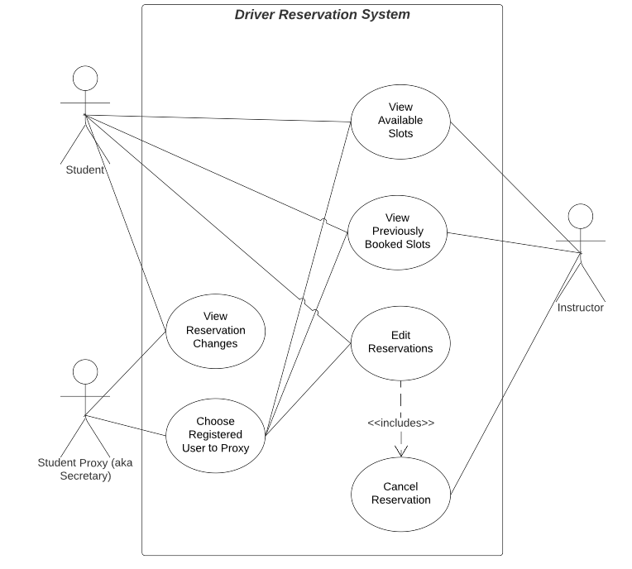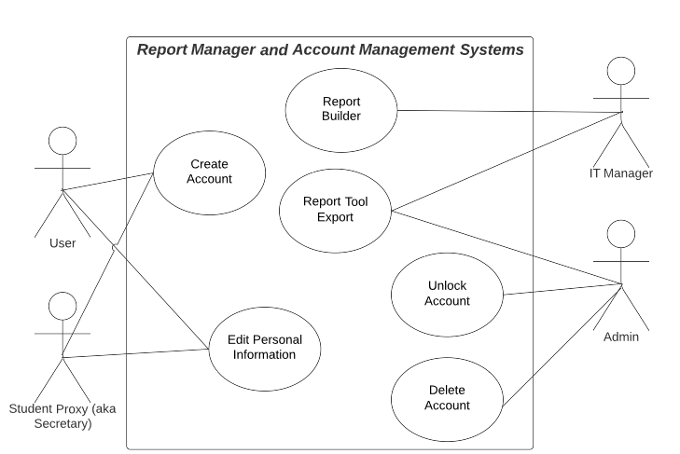

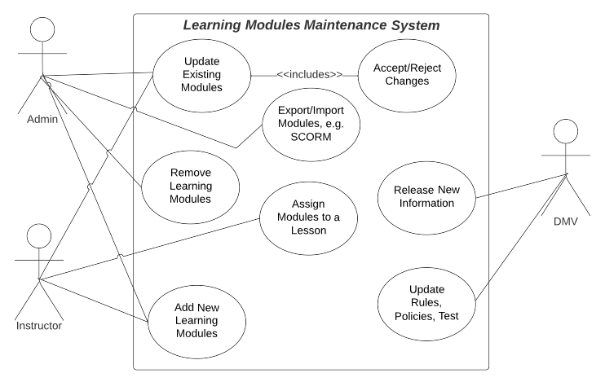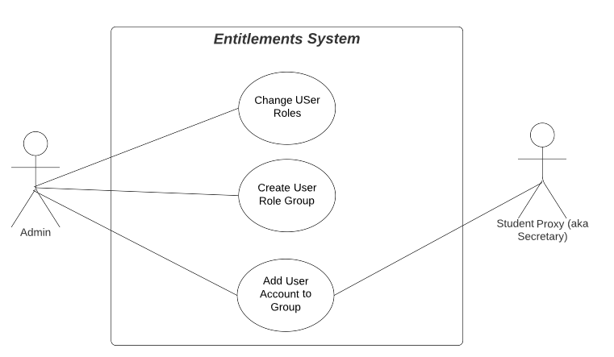

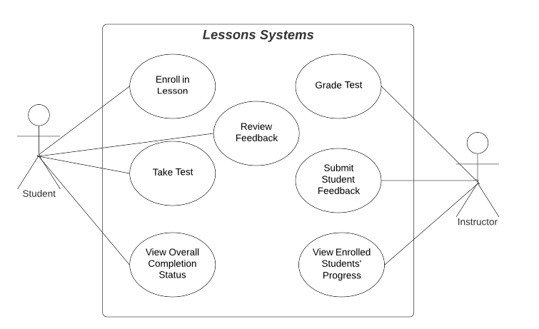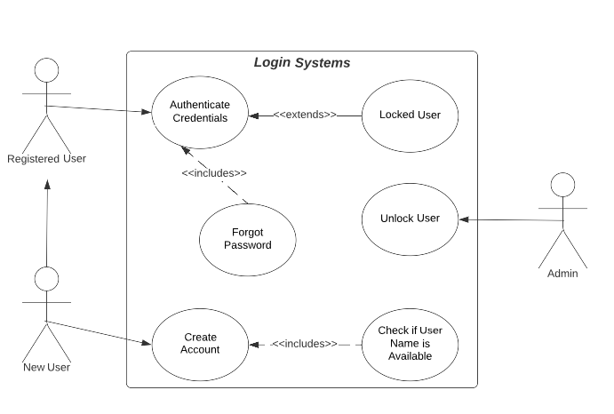

### UML Activity Diagrams

The use cases chosen for the Activity Diagrams ate for a user logging in and then going through the reservation workflow.

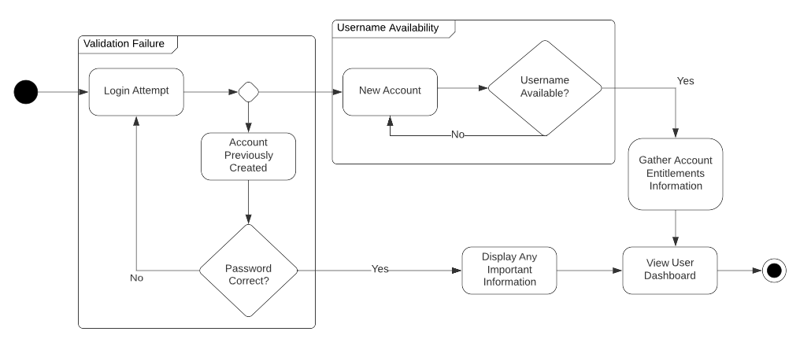

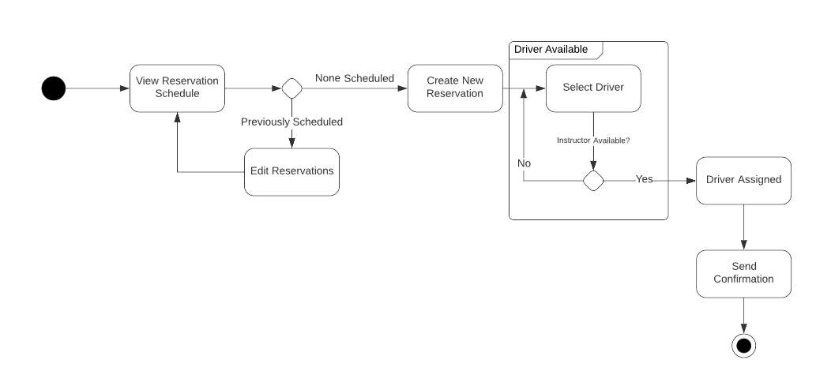

### UML Sequence Diagram

The workflow chosen for sequence diagraming is that of a person attempting to login.

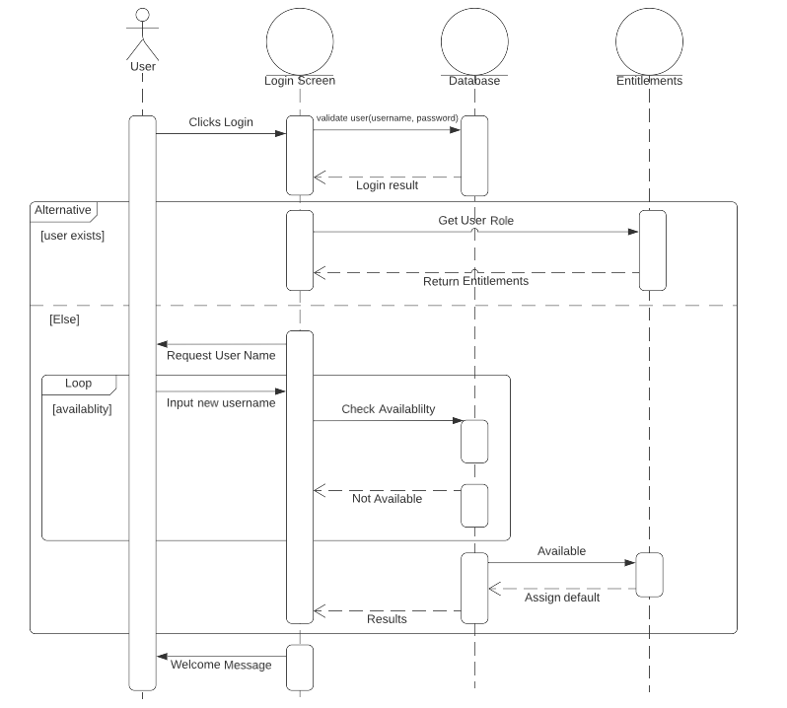

### UML Class Diagram

The classes that appear to be needed at this moment are:

* Abstract Class *User*
* Derived Classes *Student* and *Instructor*
* *Vehicle*
* *Reservation*
* Abstract Class *Instruction*
* Derived Classes *Test* and *Lesson*

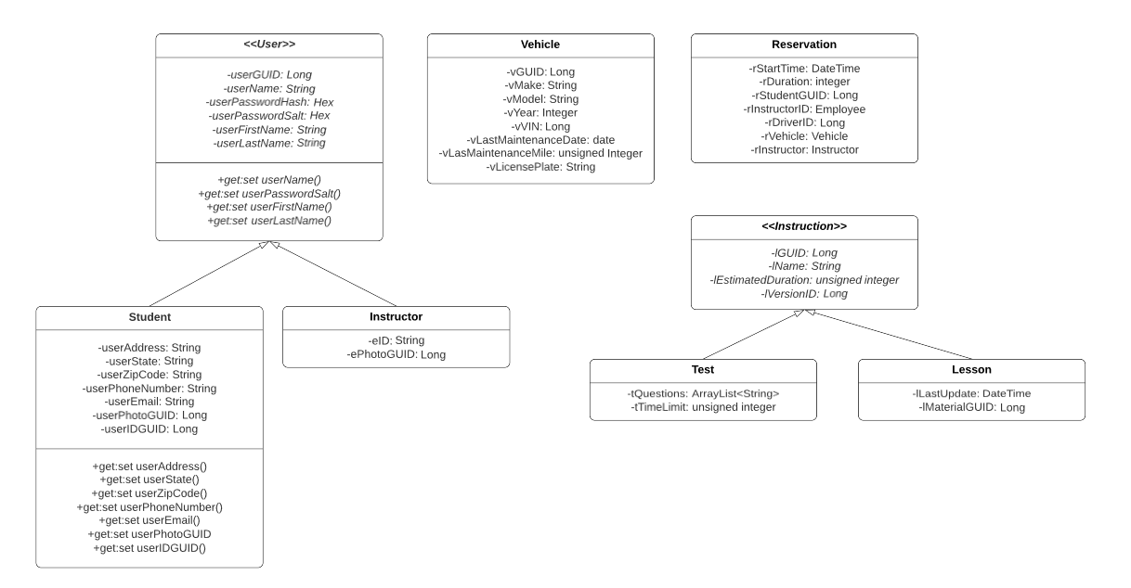

## Technical Requirements

The technical requirements needed for a web-based, LMS are as follows:

* Linux-based web server employing IAAS in 3rd-party hosing site, e.g., AWS or Google
* Scalable-architecture, e.g., Docker employing Kubernetes
* APIs designed using RESTful techniques
* LMS shall employ the SCORM standard
* LMS shall use a hybrid approach of RSA-encrypted AES-public keys for any encryption
* All router traffic will be encrypted with TSL 1.2 or higher
* All pages designed to be compliant with PWA standards
* All pages to be tested and compatible with iPhone 11 Pro iOS 14.6
* All pages to be tested and compatible with Samsung Android S10
* All pages to be tested and compatible with Chrome 102.0.X
* An uptime KPI of no-less-than 99.5% shall be set
* Any report export will be of CSV-type